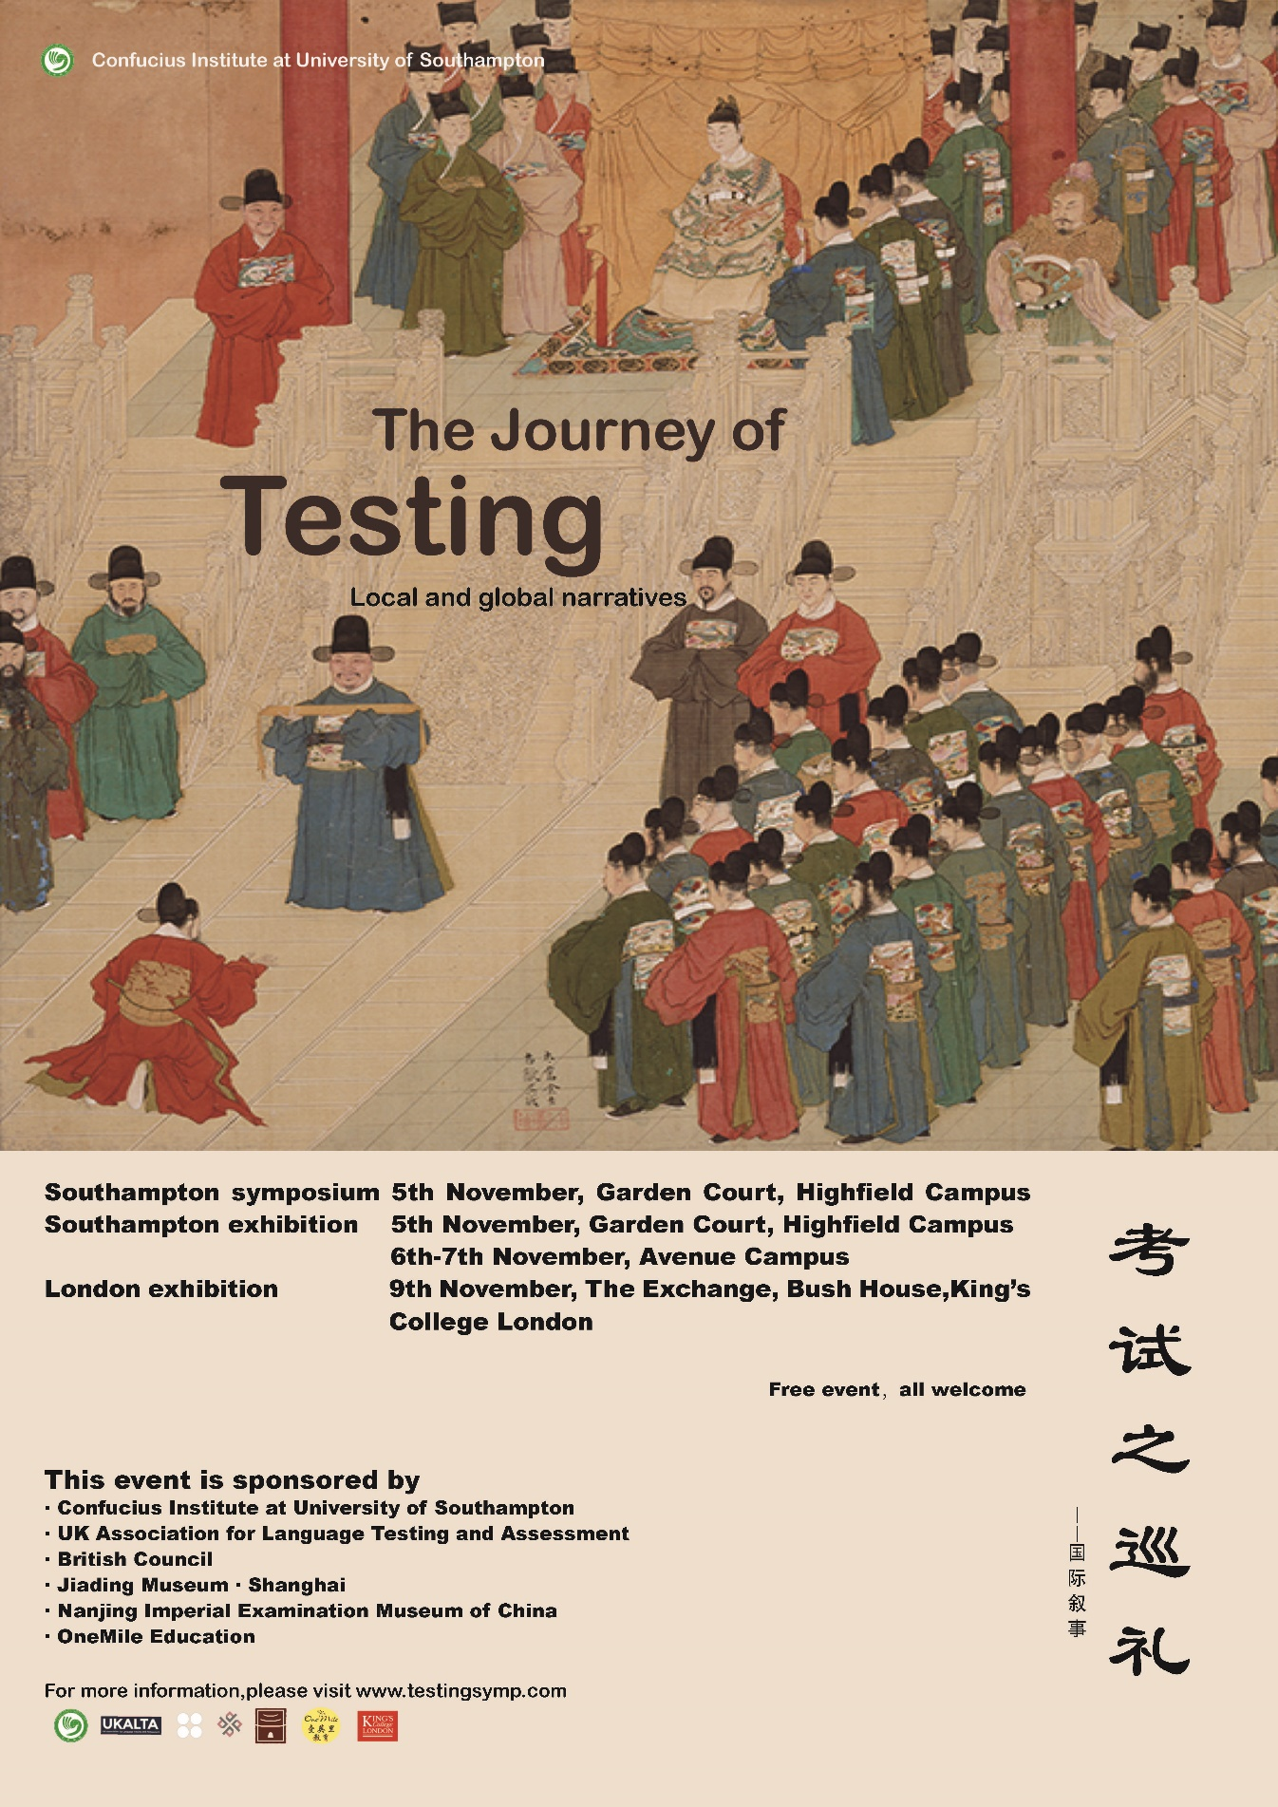

Symposium: The Journey of Testing: Local and Global Narratives
5th November 2019
Building 38 (Garden Court), University of Southampton

TIME | EVENT
9:00 – 10:00 | Registration and refreshments  Building 38 (Garden Court), University of Southampton
10:00 - 10:15 | Opening Speech  Alex Neil  Vice-President (Education) University of Southampton
10:15 –10:45 | Keynote Speech  Lei Yin  Nanjing Imperial Examination Museum of China  Social Elite and Imperial Examination System: A Silkroad Perspective
10:45 – 11:15 | Keynote Speech  Rose Clesham  Pearson  30 years of testing in the UK- back to the future?
11:15 – 11:30 | Agnieszka M. Sendur  AFM Krakow University  The changing face of the foreign language paper at the matriculation examination in Poland over the past decades. From internal to external examination
11:30 – 11:45 | Ricardo de la Garza Cano  University of Southampton  Educational testing in Mexico
11:45 – 12:00 | Chun Sum Tsang  The Hong Kong Polytechnic University  The Journey towards Chinese Language Usage Evaluation (CLUE): Insights and Observations from Designing Play-based, Age-appropriate Language Testing for Chinese-as-an-Additional-Language (CAL) Students in Hong Kong kindergartens
12:00 – 13:00 | Lunch (Museum Exhibition)
13:00 – 13:30 | Keynote Speech  Zhu Yunxian  Shanghai Imperial Examination Museum of China  Imperial Examination and Culture Transmission: A Case Study of Jiading, Shanghai
13:30 – 14:00 | Keynote Speech  Barry O'Sullivan  British Council  The Legacy of the Chinese Imperial Examinations
14:00 – 14:15 | Nathaniel Owen  Open University  Examining the legacy of psychological testing in the West: Lessons for the modern age
14:15 – 14:30 | Ahmad Alzahrani  University of Southampton  Historical exploration of the possible religious education impact on current language assessment practices in Saudi Arabia
14:30 – 14:45 | Glyn Jones  Lancaster University  Testing with tape: the impact of an old technology
14:45 – 15:00 | Coffee/Tea Break
15:00 – 15:30 | Featured talk  Liz Hamp-Lyons  University of Bedfordshire  Written examinations vs oral disputation?
15:30 - 16:00 | Featured talk  John De Jong  Language Testing Services  Historical developments of assessment in Europe
16:00 – 16:15 | Napol Artmungkhun  University of Southampton  The History of English Language Testing and Assessment in Thailand: A Story from 1960 – 2000s
16:15 – 16: 30 | Abdulhameed Aldurayheem  Liverpool John Moores University  The Development of the General Aptitude Test in Saudi Arabia
16:30 – 16:45 | Lydia May Townsend  University College London  1888: A protest against the sacrifice of education to examination
16:45 – 17:00 | Closing Ceremony

SYMPOSIUM ABSTRACTS

Lei Yin, Nanjing Imperial Examination Museum of China
Social Elite and Imperial Examination System: A Silkroad Perspective

As a well-established system in ancient China, imperial examination system not only play an important role in making of national identity, but also had a strong influence on neighbor countries which adopted it to elaborate their own legitimacy. Furthermore, through a historical survey, we find that there are candidates of Persian and Arabian origin who participate the imperial examination shortly after the system was created, we noticed that the Chinese diplomats who traveling to the far countries are the elite chosen by the system. For building the modern China, there are the very examinations elites who introduced the science knowledge and initiate the international cooperate with their foreign colleagues. A Silkroad perspective will be helpful for us to find the meaning of these historical facts.

Rose Clesham, Pearson
30 years of testing in the UK- back to the future?

Dr Rose Clesham has worked in Education in this country from before the inception of the National Curriculum in 1987. Her roles have changed over the years from teaching, running national curriculum tests, assessment design and now research and evaluation. Her talk will present a personal overview of the last 30 years of testing in this country, focusing on three themes, Trust, Standards and Technology.

Agnieszka M. Sendur, AFM Krakow University
The changing face of the foreign language paper at the matriculation examination in Poland over the past decades. From internal to external examination

The matriculation examination in Poland has always been an important threshold in a young person’s career but also a very serious undertaking in every school’s organisational and didactic duties. A language exam in some form has always been part of the school leaving examination session. For years the form of the paper, the skills and abilities tested, as well as the assessment criteria were completely up to the teacher responsible for the subject in a particular school. The last decade of the twentieth century brought significant changes in assessment literacy among school teachers and a tendency to make high-stakes exam results more comparable between different educational institutions. This eventually led to the formulation of national examination standards and a gradual introduction of an external examination system which includes the foreign language exam. In my presentation I will discuss the changing viewpoint on what should be measured at a language examination and how it should be done, and, consequently, how the examination paper evolved over the last 50 years.

Ricardo de la Garza Cano, University of Southampton
Educational testing in Mexico

This paper presentation aims at narrating how educational achievement tests and national measures have evolved in the Mexican educational system. Historically speaking, Mexico was ruled by a dictator from 1876 to 1911, whose interests did not look to education as a priority, but Catholic Church had a significant influence in making national decisions. The Dictator, Porfirio Díaz, was forced to quit his position because Mexican citizens rebelled against him since there was little support for them in terms of finance, health, security and education. After the fall of this dictatorship, the Mexican Ministry of Education (Secretaría de Educación Pública [SEP]) was founded in 1921 with the intention of a national body to implement and regulate educational reforms has faced a large number of educational phases; precisely in educational testing. Mexico was interested in collecting learning evidences to analyse educational profiles 50 years later. There have been three significant periods of evolution since the first national measure was implement for basic education programmes in the 1970; however, a lack of knowledge and resources to collect these evidences obliged federal government in Mexico and SEP to adapt international tests to be implemented to increase the educational standards in the country.

Chun Sum Tsang, The Hong Kong Polytechnic University
The Journey towards Chinese Language Usage Evaluation (CLUE): Insights and Observations from Designing Play-based, Age-appropriate Language Testing for Chinese-as-an-Additional-Language (CAL) Students in Hong Kong kindergartens

This paper presents insights and observations from having developed a play-based, age-appropriate language assessment for language minority learners in early childhood settings in Hong Kong, charting the test development venture of a Working Group affiliated with a five-year longitudinal study, C-for-Chinese@JC, which aims to offer a suite of intervention programmes to improve Chinese proficiency for ethnic and linguistic minority learners in the city. We argue that Chinese Language Usage Evaluation (CLUE) is a language testing innovation that complements traditional assessment methods with the possibility of pioneering a more age-appropriate form of assessment of, for, and as learning in early childhood settings. Concluding remarks are drawn towards the necessity of attending to ecological validity and age-appropriateness – in addition to traditional yardsticks of validity and reliability – as key criteria constitutive of the effectiveness of language testing in early childhood settings, as well as towards the ever-evolving landscape of language testing in an era attuned to pluralism, inclusion, and the empowerment of minority groups. Further developments of CLUE will also be briefly discussed.

Zhu Yunxian, Shanghai Imperial Examination Museum of China
Imperial Examination and Culture Transmission: A Case Study of Jiading, Shanghai

Jiading museum, as one of the district museum which has most powerful influence on audience engagement and community interaction, is well-known in China. In fact, the museum composed by a series of different historical monuments, relics and small museums. The most famous museum is imperial examination museum sited in the former Confucius temple of Jiading. The culture transmission, especially the local culture which viewed education as first is inherited generation by generation, and most famous figures in history are the participants of imperial examination. Recently we launched several program to link the past and present, to revive the historical memory and to generate the museum activities with cultural creative IP and products.

Barry O'Sullivan, British Council
The Legacy of the Chinese Imperial Examinations

The Chinese Imperial Examinations lasted for 1,300 years and during that period it is fair to say that a huge amount of what we currently take for granted in the way we design, deliver and report on test performance emerged. The influence of the Examinations has been truly considerable.
In this talk, I will present an overview of the test, outlining what I see as the most important lessons we have learnt from the Imperial Examinations, these relate to relating the needs of the test user (in this case the imperial government) to the test content; understanding the need for dynamic and proactive test security within a high-stakes testing environment; standardisation of test content, delivery and scoring; and recognising the positive and negative washback associated with a major high-stakes test.

Nathaniel Owen, The Open University
Examining the legacy of psychological testing in the West: Lessons for the modern age

This paper examines the social and ethical legacy of adopting merit-based systems of testing in the late nineteenth and early twentieth century and through to the present day. A climate of receptivity to merit-based social systems occurred in the west in the nineteenth century with the establishment of professional civil services in the UK (1855) and the US (1883), both influenced by the longstanding Chinese civil service and imperial examinations. Social Darwinism of the late nineteenth century emphasised the role of natural selection in social phenomena. In 1904, Alfred Binet devised a means of identifying intelligence via testing, translated and used by Goddard to classify some recent immigrants to the US as ‘feeble-minded’. At the time, poor test scores were widely seen as evidence that a lack of intelligence was hereditary for which radical solutions were needed, rather than the necessity of social reform to aid improvement for underprivileged members of society. Recent work by Saini (2019) has shown that such attitudes remain prevalent into the twenty-first century. This paper argues that the testing and education community has a duty to speak out against unethical and empirically unfounded uses of tests and advocate for fairer testing practices.

Ahmad Alzahrani, University of Southampton
Historical exploration of the possible religious education impact on current language assessment practices in Saudi Arabia

Historically, education practices in Saudi Arabia is very much influenced by the early Islamic education that took place 1400 years ago (Szyliowicz, 1973, p. 51). This is apparent in the structure of the current schooling system that is similar to the early notion of madrasa (school) which was located in Mosques (Muslims worship place) (Tibi, 1998). For example, in the madrasa, the “preacher‐like” image of the teacher is the dominant one (Elyas and Picard, 2010). Although Islam encourages learning foreign languages, much research that looked into the religious view of education found controversy in the teaching of English language as a language that carries Western values that may not be aligned to the Islamic values (Elyas and Picard, 2010). Therefore, there is a similar need to look into how this has influenced assessment practices in Saudi English classrooms especially when we know that the early Islamic assessment method ijazah (a means of assessing academic accomplishments of pupils (idriz, 2007) is still practiced in many Saudi institutions. Therefore, this presentation will raise a number of questions in relation to assessing students in English with reference to Islamic views of education from teachers’ point of view.

Glyn Jones, Lancaster University
Testing with tape: the impact of an old technology

The use of magnetic tape to record sound was developed in Germany in the 1930s, and by the late 1950s commercial tape recorders were widely available and affordable. For language testing, this new technology offered enormous benefits. Hitherto, the assessment of listening comprehension relied on a live speaker, reading aloud form a written script, in the exam room. The assessment of speaking had to be done in real time by a rater on the spot. The advent of audio brought potential advantages for assessment of listening: standardization (candidates in different exam rooms could be exposed to substantially the same sample of spoken language) and variety of text type (no longer limited to scripted monologues). Furthermore, audio tape could also be usefully applied in assessing speaking, as a candidate’s performance could be recorded and rated off-line. However, high stakes testing bodies were slow to take advantage of these potential benefits. The presenter will give examples of early applications of audio tape in the assessment of listening and will describe two initiatives to apply the technology in the assessment of speaking: the ARELS test and the Test of Spoken English (TES).

Liz Hamp-Lyons, University of Bedfordshire
Written examinations vs oral disputation?

The Chinese Imperial examination system has a long history; but so does the tradition of oral disputation. In this paper I briefly overview both written and oral forms of ‘examination’, broadly defined, and consider how each of them has shaped the world in which it has been located—across time and geographic space.

John De Jong, Language Testing Services
Historical developments of assessment in Europe

From ancient times, through the middle ages, the renaissance and right until the French revolution school examinations as well as civil service examinations had been a form of oral or performance assessment: a demonstration of manual or verbal skills judged by one or more “masters of the trade”. Yet as early as the mid-16th century European scholars became aware and admired the custom of written examinations they encountered in China. It then still took several hundred years before educationalists managed to convince authorities to adopt a form of written examinations both in schools as in civil service. Around the beginning of the 18th century academic written exams are first mentioned and only around the mid-19th century written exams were introduced in civil service in England. By the beginning of the 20th century psychological testing was elaborated as a rigorous discipline, first in Europe but soon also in the United States. The principles and rules developed in psychological testing were soon to influence educational and professional testing and constituted a first substantial improvement by western society on the age-old Chinese form of assessment.

Napol Artmungkhun, University of Southampton
The History of English Language Testing and Assessment in Thailand: A Story from 1960 – 2000s

This presentation aims to present the history of English language testing in Thailand. This talk will review the English language testing in practices, which is the consequences of the relationship between English language teaching and testing, which primarily occurred in 1960 to provide the contextualised background in a Thai context. Subsequently, the primary attention of this talk will be paid to the seven concerning issues regarding to the language tests that they were thoroughly discovered by local scholars in 2000s, including 1) the washback effects, 2) the language tests in school admissions, 3) the language test validity, 4) the emergence of standardised tests, 5) the reflection of social expectations and values, 6) the implementation of computers and technology in language testing and assessment, and 7) the outcomes of policy implementation. This talk will end with the impacts of the language testing and assessment in practices on local stakeholders who encountered these concerning issues in this context and suggestions from local scholars.

Abdulhameed Aldurayheem, Liverpool John Moores University
The Development of the General Aptitude Test in Saudi Arabia

Higher education in Saudi Arabia started in the 1950s. However, it was unpopular among people to go to universities at that time. With the rise of oil industry in the country, life has started to witness radical changes in urbanising more people in cities and its impact on social development. The number of schools built, hence, has increased and new different jobs have been created. Because of that and along with many initiatives by the government, the number of university applicants who will fill these jobs in the future have increased dramatically in the following decades. In response to admission high demand, the National Centre for Assessment founded standardised high stake tests, the General Aptitude Test, in Arabic, and later on the Scholastic Achievement Test to refine applicants to their chosen faculties. The tests caused disputes over their applications. Although many studies have been conducted to investigate their reliability and validity to predict students success in university, my research focuses on the verbal section of the GAT to predict students’ performance in learning English as a foreign language. The findings of the study will report on two folds; cross-linguistic influence and the power of the test to predict students’ performance.

Lydia May Townsend, University College London
1888: A protest against the sacrifice of education to examination

Little academic attention has been given to the protest given to the British parliament in October 1888 against the evils of competitive examination. After being presented to parliament, it was subsequently published in the Nineteenth Century magazine and garnered significant media interest. This presentation revisits the protest. It compares the claims made about examination in the protest to current discourse concerning examination. Specifically, it looks at examination's affects on teaching and learning in British schooling.

The event is sponsored by
- Confucius Institute at University of Southampton
- UK Association for Language Testing and Assessment
- British Council
- King’s College London
- Nanjing Imperial Examination Museum, China
- Jianda Museum Shanghai, China
- One Mile Education China

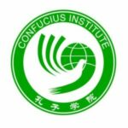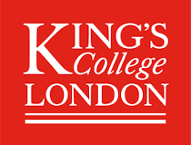

The symposium is organised by
Special Interest Group in Language Testing and Assessment (SIGLTA)
at the University of Southampton

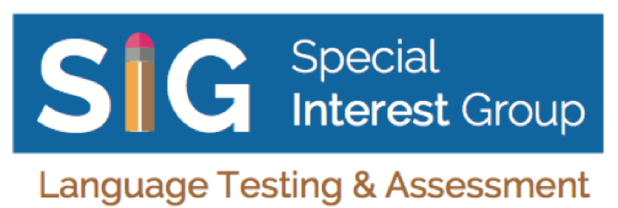

Transportation information
For the Symposium On 5th November at Garden Court, Highfield Campus, University of Southampton. Post-code: SO17 1BJ

By Car: Visitor parking: May be available by prior arrangement, please contact your host. The closest Pay and Display parking is at Highfield Campus, accessed from University Road

By Rail: Fast trains from London and Bournemouth/Weymouth stop at Southampton Central and Southampton Airport Parkway. Trains from Portsmouth and Bristol/South Wales stop at Southampton Central. There are also regular trains from major airports such as Gatwick and Heathrow to Southampton Central. You can find details of routes and timetables on the National Rail website.

By Coach: National Express provides regular coach services to Southampton from central London, Heathrow, Birmingham, Bournemouth and the north. Southampton Coach Station is at Western Esplanade, in the city centre, close to the train station.

By Bus: You can continue your journey to our campuses using our own Unilink bus services. The Unilink bus fare is £2 for a single or £3.50 for an all-day pass.

By Taxi: Taxi fares from the city centre are usually £6-10, depending on the range of the journey.

Accommodation Options:
Elizabeth House Hotel
Highfield House Hotel

